To determine the problems that are occurring across the St. Himark, we first built the taxonomy for 1) Event and 2) Resource categories. We built the taxonomy with an assumption that one message can belong to more than one category, e.g., a message can indicate that there are needs for both water and food. The reasoning for this assumption comes from the possibility that priorities for resources may change over time, hence we need to take all information into account. Related events that may occur during and after earthquake are included to characterize the condition as a whole. The sliding window is flexible within the control board, window width size can be adjusted to capture a particular timeframe.

**Characterize conditions across the city**

From the main control board A, selection of “Earthquake” show clearly three times that the earthquake strikes. We used the these peak to make prediction for the times earthquake strike.

To consolidate this point, we explore the detail from corresponding messages. The WordStream supports highlighting the keywords in the corresponding categories. Besides, while mousing over terms, WordStream highlight the co-occurrences words alongside keywords from the actual messages. Location of these messages are also emphasized in the “Location” stream and in the geolocation map.

The first time earthquake strike is around 2:31:30PM, April 06, 2020.

The second time earthquake strike is around 8:34:18 AM, April 08, 2020

The third time earthquake strike is around 3:03:20 PM, April 09, 2020

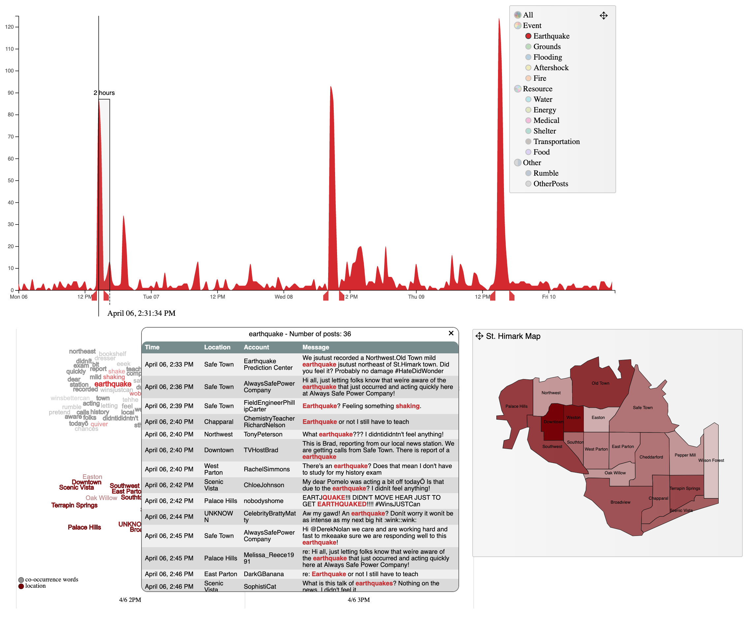

In the first strike, we can explore the affected location by demand-on-detail with highlighted location on the map, corresponding text on the WordStream.

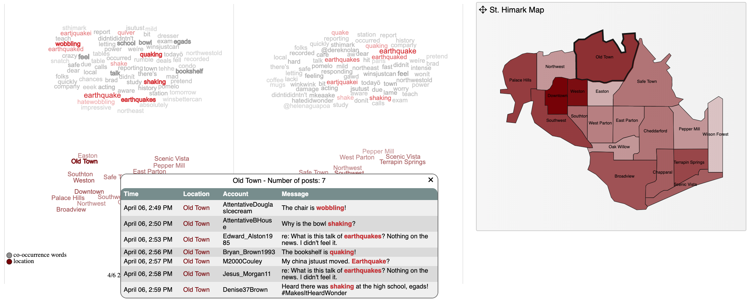

From this approach, the affected location in the first strike are ___________

Likewise, the second strike happened at _____, the affected locations are

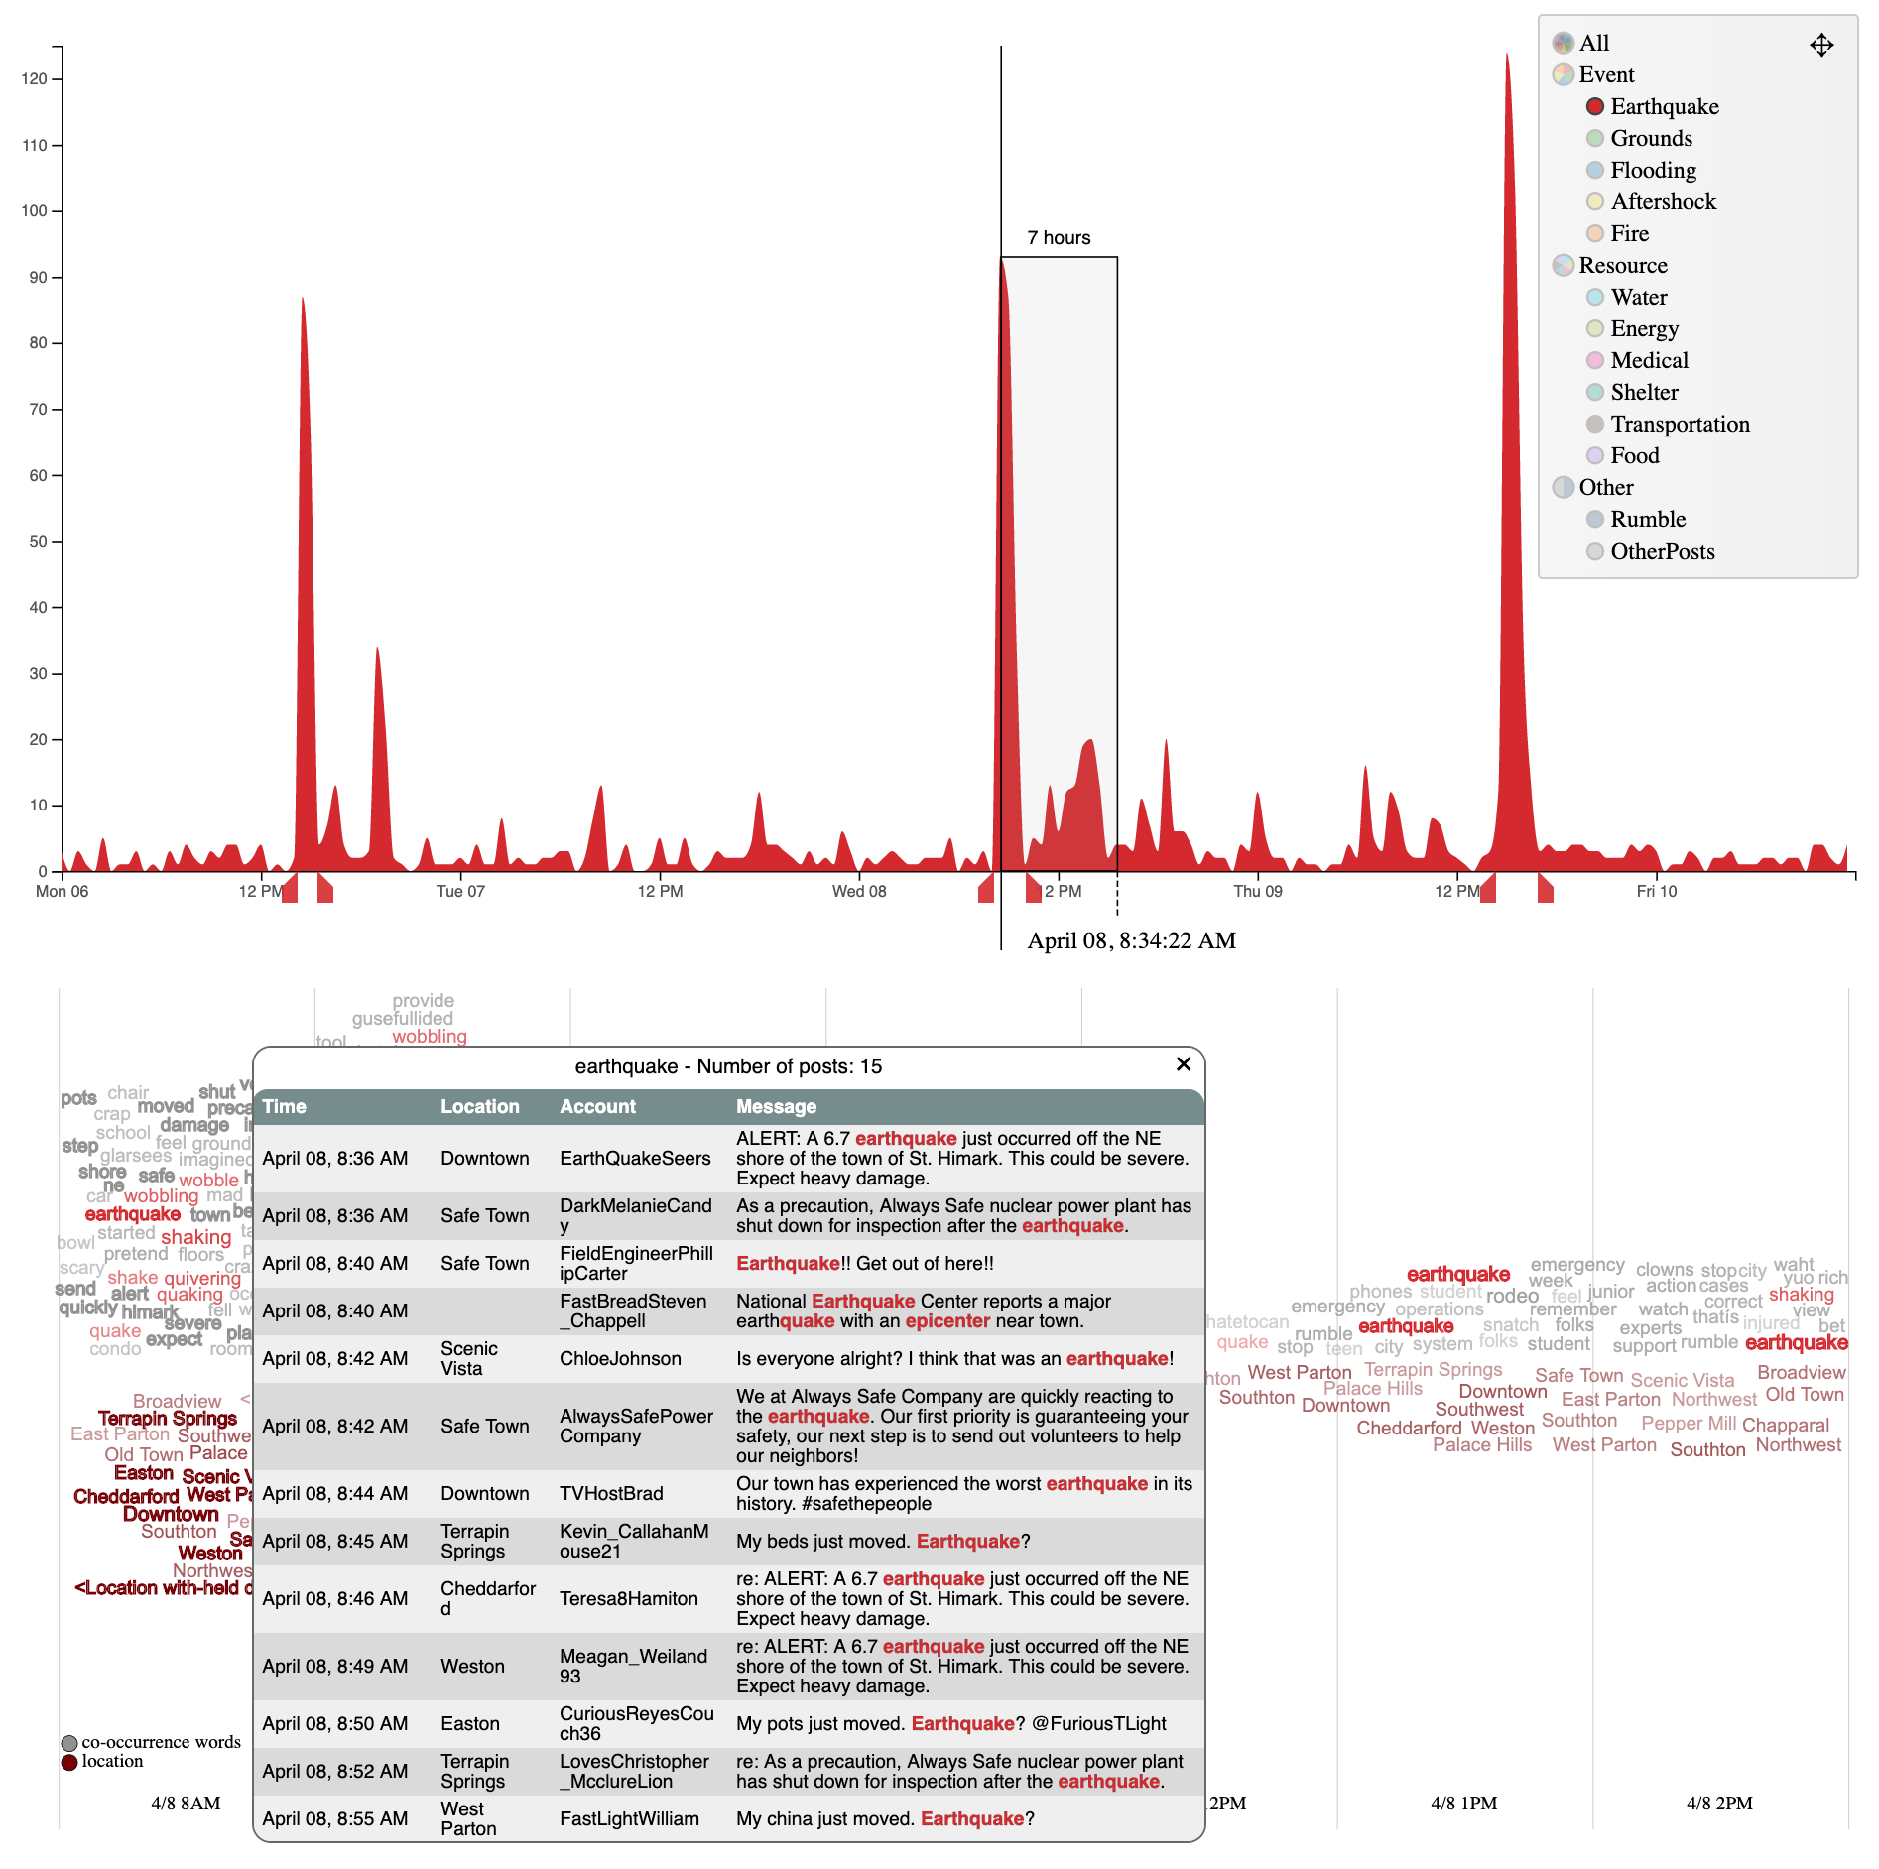

**Recommend how resources should be allocated at 5 hours and 30 hours after the earthquake**

To characterize the needed resource at 5 hours and 30 hours after the earthquake, the window width size should be 6 and 31, respectively, to fully explore the condition.

Right after the first strike, the main concerns were food (with messages about food complain), power (related to AlwaysSafePower Company). In this strike, the effect is not very severe, because medical or emergency stream is very minimal. However, after 5 hours, main concern of people is “Shelter” (buildings). This main concern comes from _________.

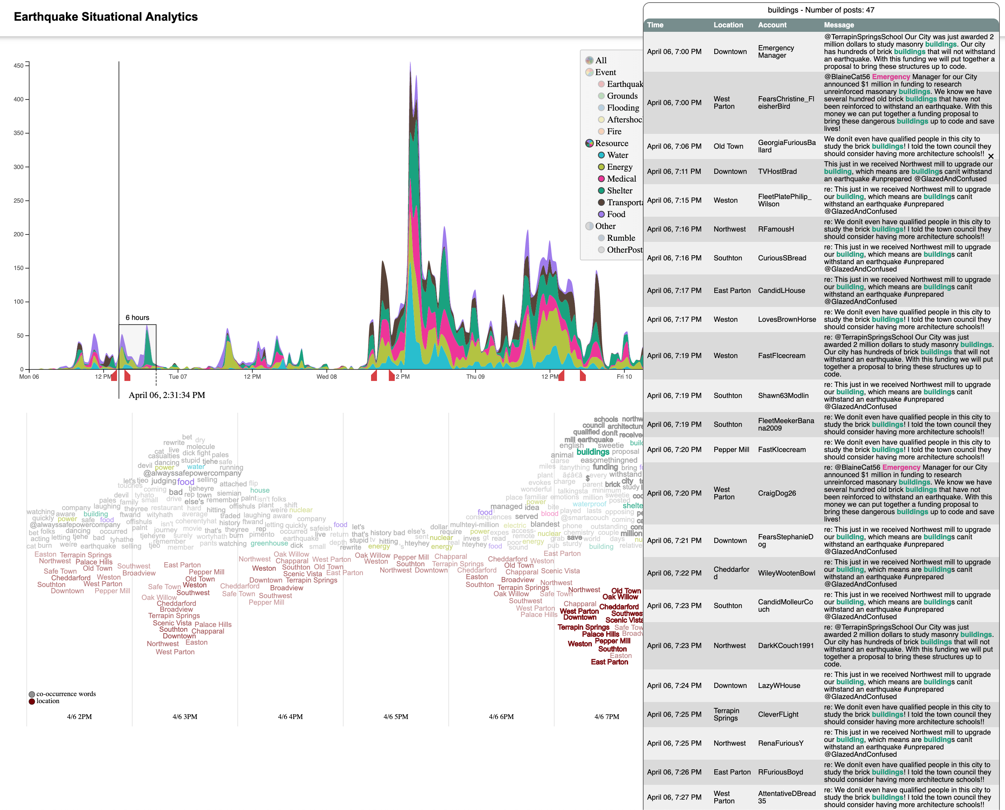

After 30 hours:

